John D Ragan  STATE REPRESENTATIVE  33rd LEGISLATIVE DISTRICT  425 5th Avenue North  Cordell Hull Building 614  Nashville, TN 37243  (615) 741-4400  representative john ragan  Delivered on Paper and Electronically |   House of  Representatives  State of Tennessee  NASHVILLE  October 16th, 2020 | COMMITTEES  HOUSE EDUCATION COMMITTEE  CHAIR HOUSE EDUCTATION K-12 SUBCOMMITTEE  GOVERNMENT OPERATIONS COMMITTEE  CHAIR JOINT GOVERNMENT OPERATIONS EDUCATION, HEATLH AND GENERAL WELFARE SUBCOMMITTEE  JOINT GOVERNMENT OPERATIONS COMMERCE LABOR TRANSPORTATION AND AGRICULTURE SUBCOMMITTEE  HOUSE NAMING, DESIGNATING, PRIVATE ACTS COMMITTEE  CO-CHAIR NCSL NUCLEAR WORKING GROUP  NCSL EDUCATION COMMITTEE  SOUTHERN STATES ENERGY BOARD  EXECUTIVE COMMITTEE  JOINT VETERANS’ CAUCUS

To: Dr. Penny Schwinn, Commissioner of the Department of Education
Subject: Department of Education Information on Comprehensive Literacy State Development Federal Grant Program - PR Award Number and Application, S371C200013
Reference: a. Education Summer Study Hearings, 22-23 September 2020
b. Textbook and Instructional Materials Quality Commission
c. Tennessee’s K-12 Standards Review Process
d. T.C.A. §§ 49-1-310, 49-1-311, and 49-1-312
e. T.C.A. §§ 49-6-2201 through 49-6-2203
f. Governor Bill Lee’s State of the State Address, 3 February 2019
g. T.C.A. §§ 4-5-102(10) and 4-5-102(12)

Dr. Schwinn:

- This letter is an inquiry concerning your department’s actions on the subject issue. In reference a., above, you announced that your department was involved in several federal grant processes. However, you failed to sufficiently elaborate on details to committee members. Since then, the subject grant has come to the attention of Education Committee and Government Operations Committee members. As a result, questions and concerns have arisen.

- A review of the subject document reveals that it appears, on first examination, to be in conflict with reference b., above. Additionally, there also appears to be conflict with reference c., above, as well. A detailed explanation to Education Committee members and other stakeholders to clarify these apparent problems seems to be in order.

- Unfortunately, the subject grant also appears to involve organizations and entities previously closely associated with “Common Core.” References d. through f., above, among other things, specifically disallow “Common Core” involvement and use in Tennessee’s K-12 system. Therefore, serious concerns arise regarding this issue and the subject grant implementation.

- Legislation for early childhood literacy, a focus of the cited grant, had been under consideration prior to the COVID-19 crisis. Consequently, it is appropriate, that prior to implementation, this grant be formally presented to Education Committees in both General Assembly chambers. Moreover, such prior presentation would also be appropriate as well as for other K-12 education system stakeholders.

(Continued on page 2)

(Continued from page 1) Page 2

- Finally, reference g., above, clearly specifies that executive policy is operative only on internal procedures and personnel of that department. Any executive department procedures or mandatory action requirements of citizens not employed in the department require legislation or rule enactment. Therefore, please explain specific legislative authorities and/or rule(s) that any grant actions by entities external to the department will be executed.

- In summary, this letter requests your timely acknowledgement and explanatory response to this communication’s concerns by 23 October 2020.

Sincerely,
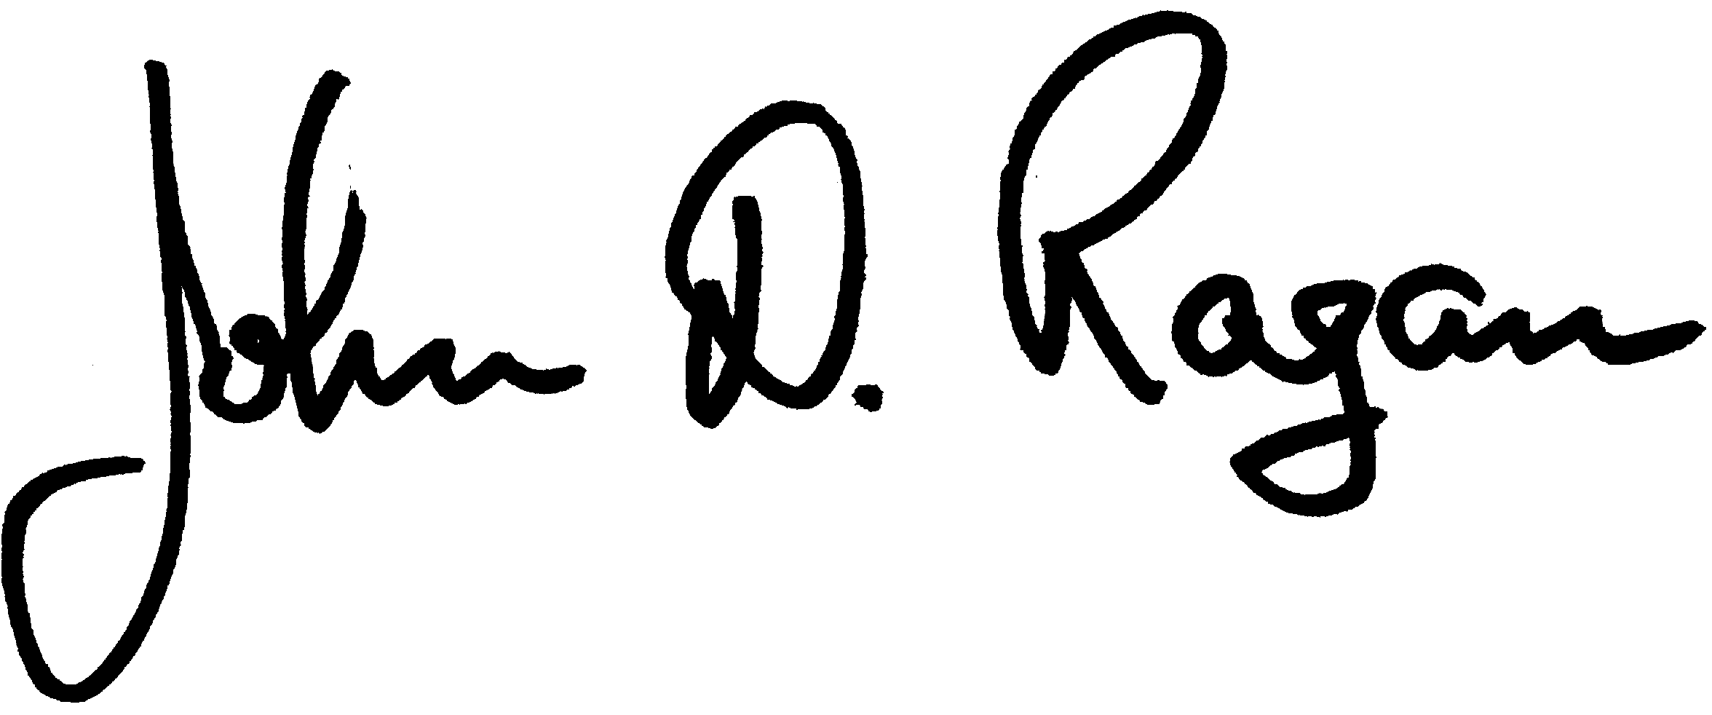
John D Ragan
Chair, Joint Government Operations Subcommittee on Education, Health and General Welfare

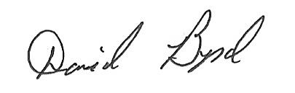
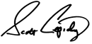
Scott Cepicky David Byrd
Education Committee Member Education Committee Member
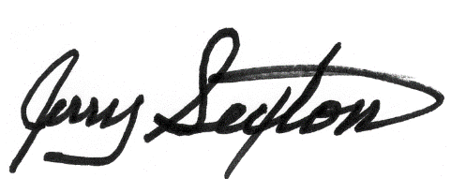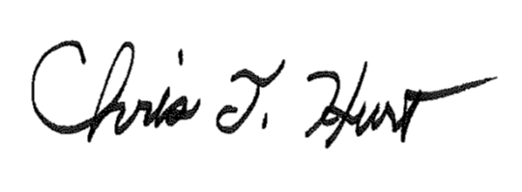
Jerry Sexton Chris Hurt
Education Committee Member Education Committee Member
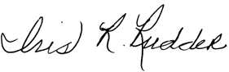
Iris Rudder Terri Lynn Weaver
Education Committee Member Education Committee Member
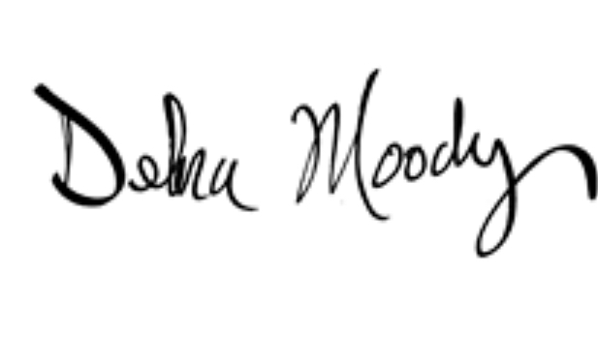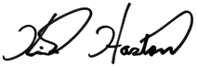
Debra Moody Kirk Haston
Curriculum, Testing, & Innovation House Education Committee
Education Subcommittee Chair Vice Chair

cc: Speaker Cameron Sexton
Leader William Lamberth
Chairman Jeremy Faison
Chairman Martin Daniel, House Government Operations Committee
Senator Kerry Roberts, Chair, Senate Government Operations Committee
Senator Janice Bowling, Vice Chair, Joint Government Operations Subcommittee on Education, Health and General Welfare
Senator Delores Gresham, Chair, Senate Education Committee
Mark White, Chair, House Education Committee
The House Education Committee Members

